# CS 255 System Design Document Template

This template lays out all the different sections that you need to complete for Project Two. Each section has guidance to prompt your thinking. You will need to continually reference the interview transcript as you work to make sure that you are addressing your client’s needs. There is no required length for the final document. Instead the goal is to complete each section based on what your client’s needs are. Remove this note when you are finished, and replace all bracketed text with the relevant information.

## UML Diagrams

### UML Use Case Diagram

### UML Activity Diagrams

### UML Sequence Diagram

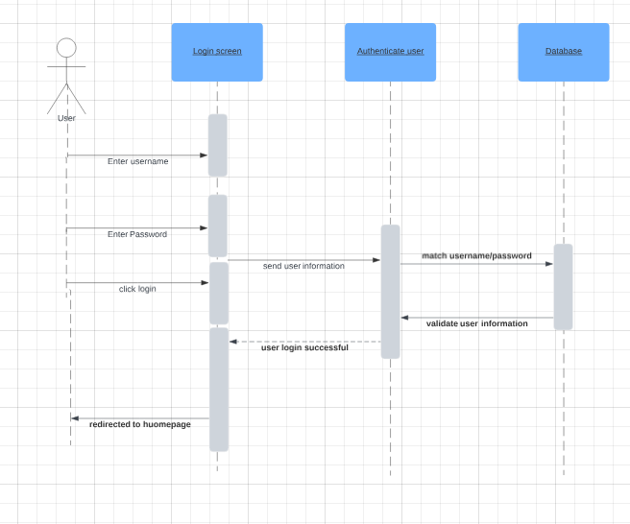

### UML Class Diagram

## Technical Requirements

Host Hardware Prerequisites:

A minimum of one physical server

Network cables for the equipment and server

Monitor, mouse, and keyboard for interaction

Sources of power

ISP (Internet service)

Mechanical Hardware Specifications for the Client:

Laptop or desktop computer

Ethernet cable or Wi-Fi router for networking

Energy sources

ISP (Internet service)

Host Software Prerequisites:

1.0 Windows Server operating system

DriverPass Application

Docker software for virtual machine traffic management

Security software that safeguards confidential data against unauthorized access.

Implementing Software Client Prerequisites:

Web browser application (e.g., Mozilla Firefox, Google Chrome)

Operating system (including Mac, Linux, Windows, and others)

Securing software to safeguard confidential data.

Development Requires the following:

Computers equipped with programming software (e.g., Visual Studio, Eclipse)

Connection to the Internet for server upload

Network administration tools for suspicious traffic monitoring

Establishment of infrastructure Server location or cloud provider (required)